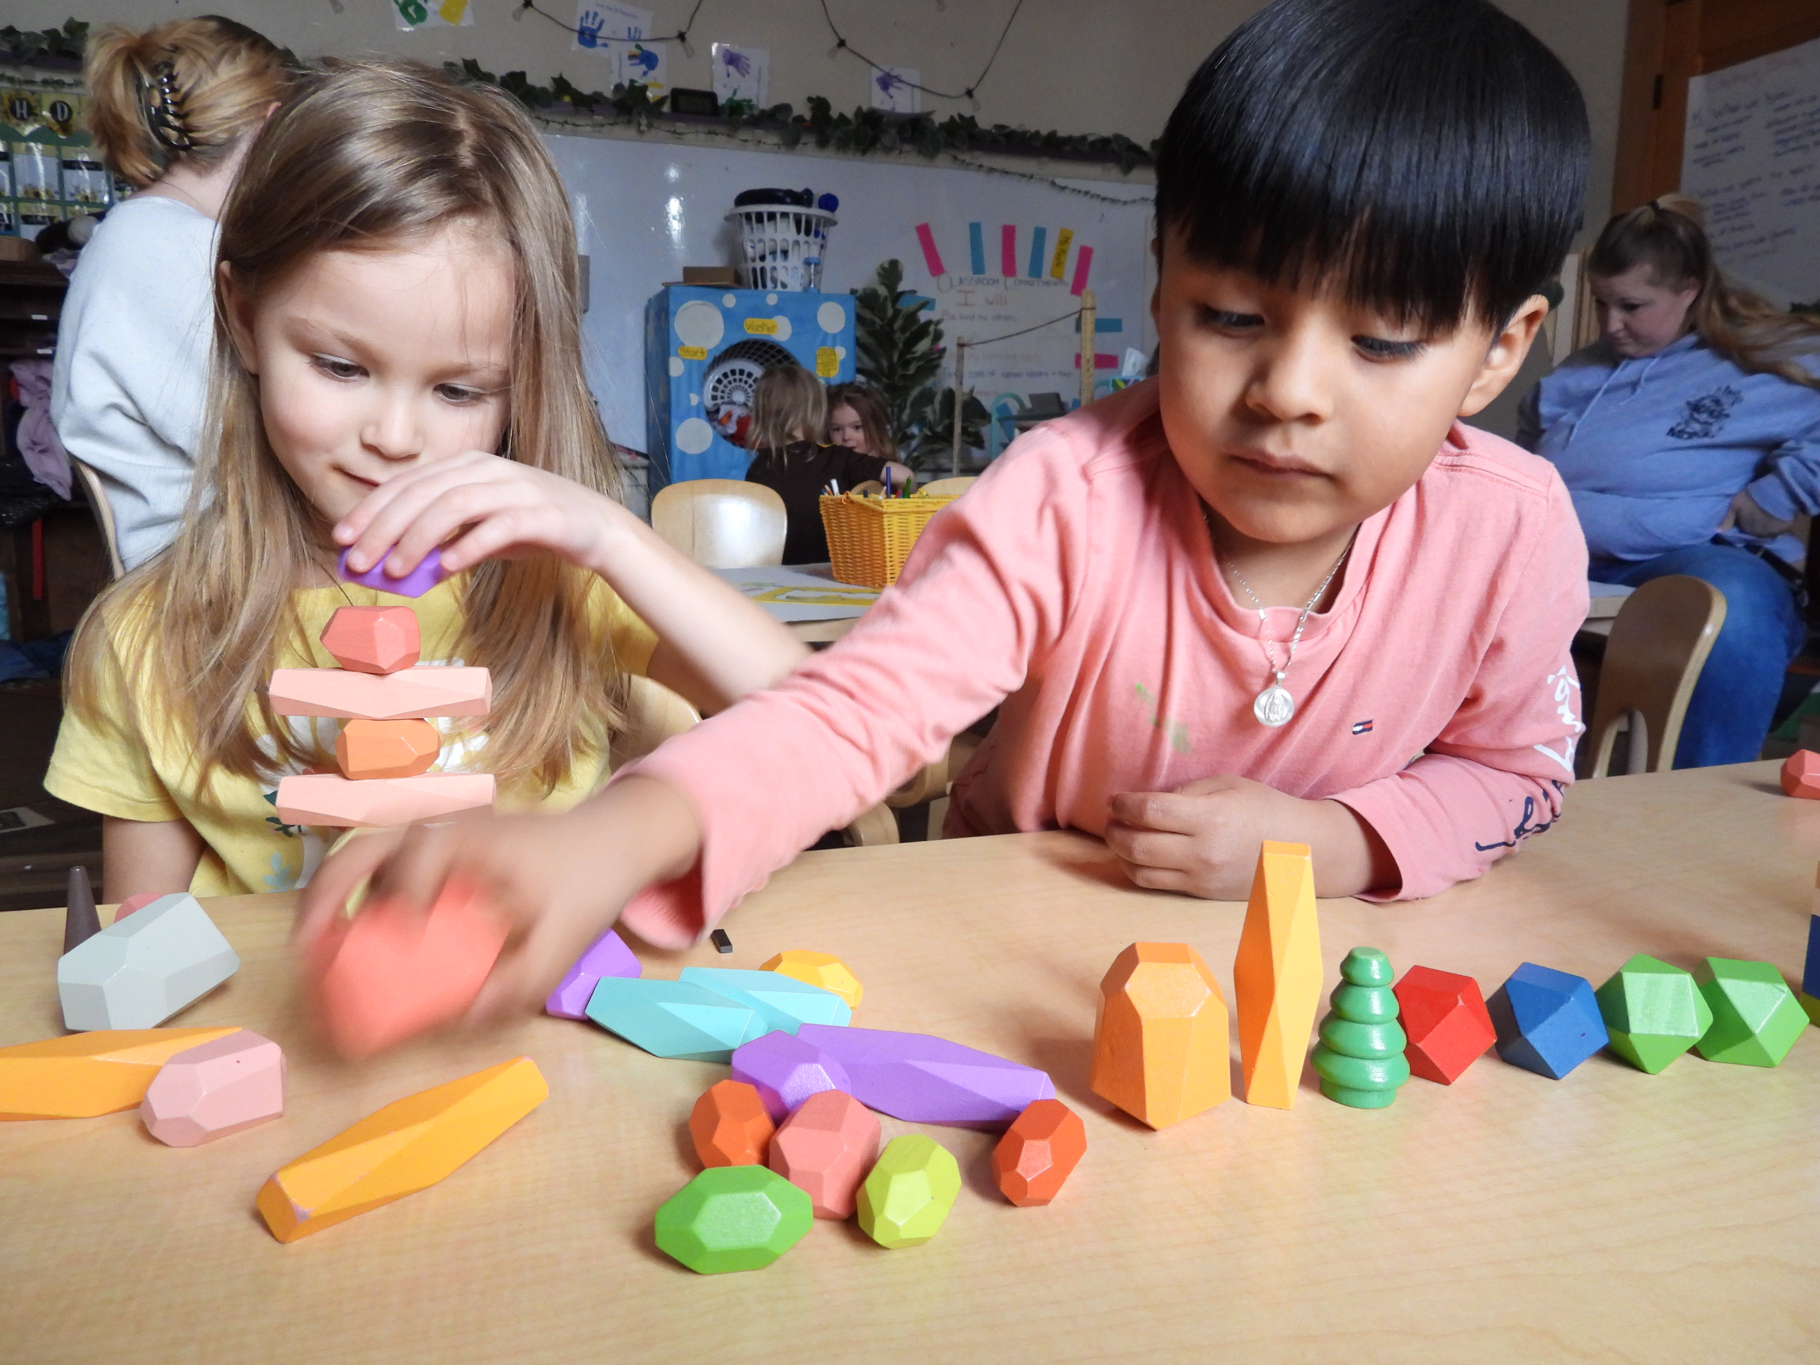

2024-2025
Annual Report
Information Technology Solutions
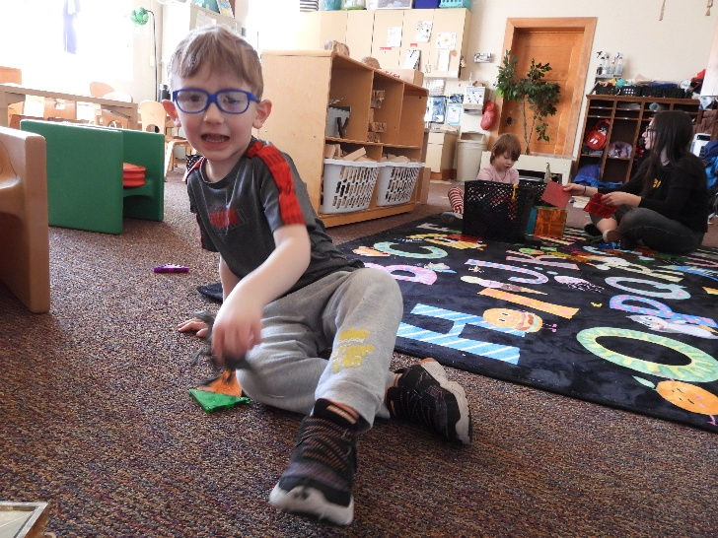
~ “The school staff is very knowledgeable about everything, there is great communication, and they offer the best services for the children.” ~ Quote from a Head Start of Laramie parent in the family satisfaction survey

School Readiness
Preparing children for higher education is the foundation of what we do at LCDC/HSL. Throughout the year, staff use a research-based curriculum to work with children in the following developmental areas: Social/Emotional Development, Approaches to Learning, Physical-Perpetual, Gross & Fine Motor Skills, Language & Literacy, and Cognitive Development. Children become more aware of themselves, their peers, and adults. Children’s skills improve daily to give them the best foundation to succeed in school and life.

LCDC/HSL works with ACSD1 and DPDC to transition children into the public school prepared and ready to work. Families receive information that will help them advocate for and support their children as they move forward.

UW Collaboration:
- Social Work interns have been an active part of our program for seven years. They work with the staff to support families throughout the year.
- Nursing students assist Head Start in supporting and educating children and families by planning and participating in events, such as the Teddy Bear Clinic, collecting heights and weights for BMIs, assisting with Scooterama, and the annual Health Fair.
- Education and Disabilities students observe and work in the classrooms to gain knowledge about preschool-aged children and plan activities to support children’s growth and development.
- A University of Wyoming professor, lecturer, and disabilities expert is the Early Childhood Specialist for the LCDC Board of Directors.

*As well as the support LCDC/HSL receives collaborating with the University, LCDC/HSL also works closely to support children, families, and staff by working with WYECBC and WYECPLC.

Funding

Public and Private Funds Received:
- Federal Funds awarded by the Dept. of Health and Human Services— Aid for Children and Families:
$1,098,219.00
- United Way Allocations: $29,378.64.
- Private Donations: $5,852.51.
- USDA/CACFP: $59,183.90

Total Funding: $1,192,634.05

Expenses:
- Training/Technical Assistance: $13,671
- Wages/Fringe: $794, 235.78
- Supplies: $71, 567.37
- Contractual: $47,416.14
- Other (i.e., rent): $185,303.74

Total Expenditures: 1.112.194.03

Proposed Budget for Upcoming Year:
- Training/Technical Assistance: $13,671
- Wages/Fringe: $863070.32
- Supplies: $34,400
- Contractual: $63,320
- Other (i.e., utilities) $137428.68

Total: $1,111,890

Mission Statement
Laramie Child Development Corporation/Head Start of Laramie partners with families and the community to nurture the success of every child and family, strengthen relationships, and enrich quality of life through learning, respect, and trust.



This annual report is shared with the Laramie Child Development Corporation/ Head Start of Laramie Policy Council and Governing Body and partnering agencies throughout the community. We also post it on our website and Facebook page.

Parent/Family and Community Involvement:

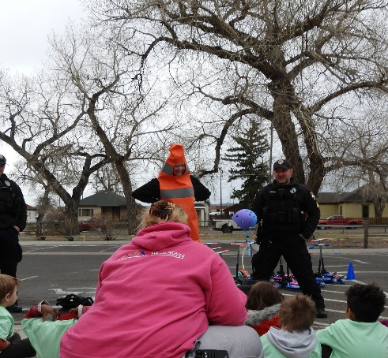
Family Goal Setting: This unique opportunity for families gives Head Start of Laramie family advocates the chance to work closely with families to support goal setting efforts. Together the family and family services staff focus on building realistic goals and attainable action steps for the families to achieve success for themselves and their children. Family advocates provide community resources for families to increase efforts in achieving goals and supporting their needs.

Family Engagement Events: Families can join with their children and staff in supporting individual and program goals when they attend Head Start Family functions.

ns.
The annual Health Fair, Teddy Bear Clinic,
and the newly added annual Scooterama are opportunities for children and families to learn more about health and nutrition, the advantages of receiving annual well-child and dental exams, and pedestrian and helmet safety. These health and safety educational opportunities involved participation from the University and the Laramie Police Department, and many other agencies in the community at large.

Education staff prepare events that support what the children are learning in the classrooms and give parent/caregivers and families the chance to be involved in their children’s learning in and out of the classroom.

Mental health services were available and provided children, families, and staff the support needed over the course of the year. Professional development opportunities support staff in building skills and strategies for preschool children.

LCDC/HSL would like to thank:
Laramie Police Department
Laramie Fire Department
Developmental Preschool and Day Care
University of Wyoming Assistant Professor
Human Nutrition and Food Program
— Grace Shearrer
UW Nursing Program Students
Wyoming Pediatric Dentistry- Laramie
Dr. Daiva Olipra, MD
WYECBC
WYECPLC

~ “Good school and everyone is prepared! Head Start is our second home!” ~
Quote from a parent/caregiver on the Head Start survey

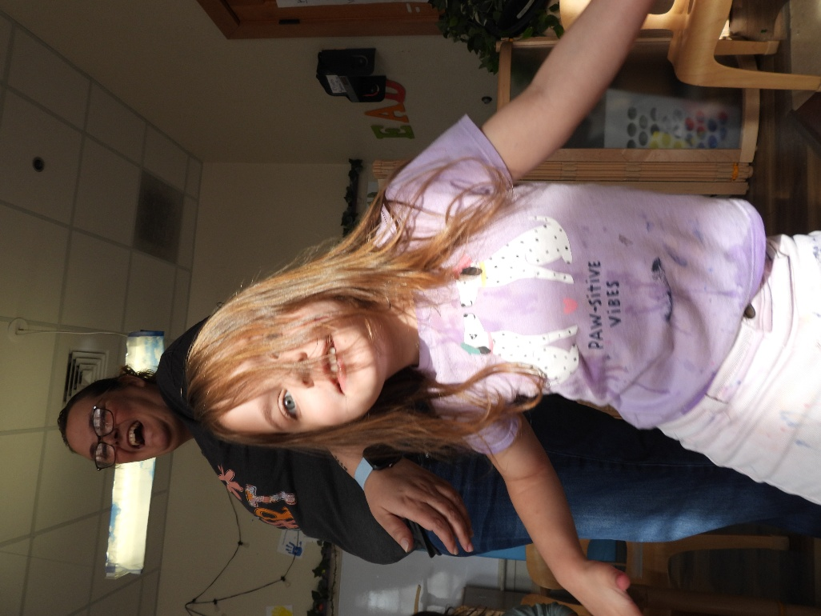

ANNUAL STATISTICS:

Total # of Children Served: 69

Total # of Families Served: 62

Ave/Monthly Enrollment: 98%

Percentage of eligible children served: 6 %

# of Child with Disabilities in Enrollment: 32 children, which is 46% of total enrollment

# of Children who are Dual Language Learners: 14 children

Head Start Staff had over 50% Head Start children or past parents/grandparents

Medical Exams: 100%

Dental Exams:
100%

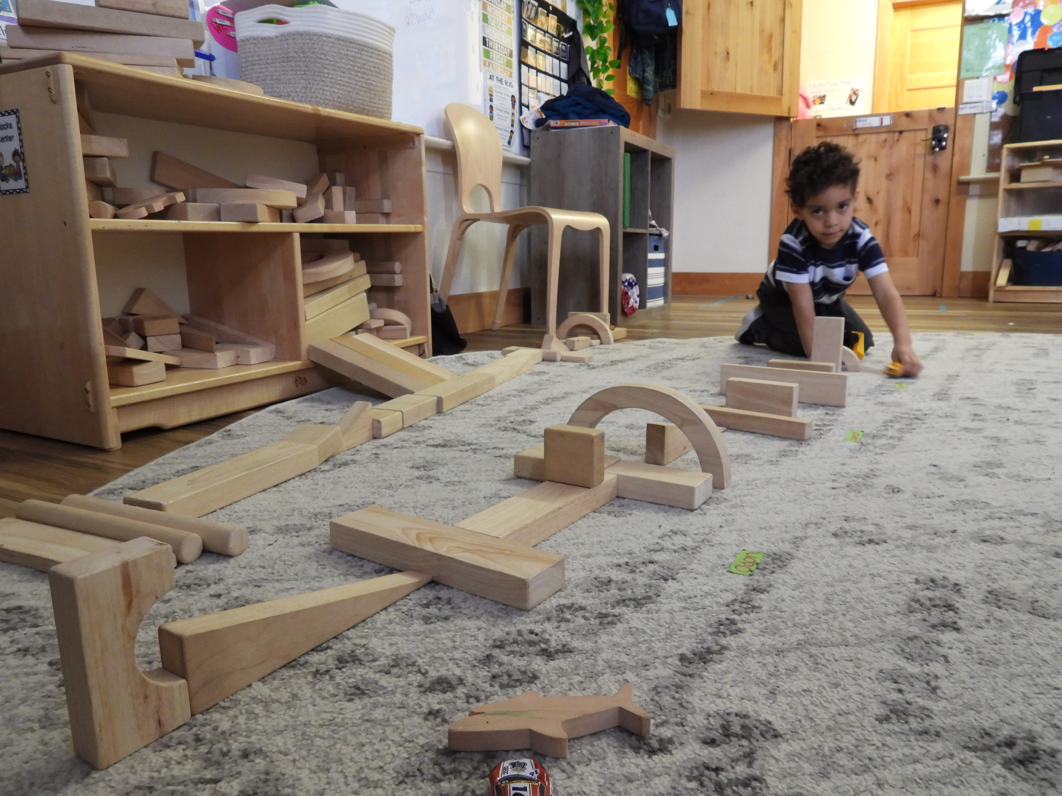

Annual Financial Audit
An annual audit was prepared for LCDC/HSL by Grooms and Harkins, P.C., an independent auditing firm. There was one finding for late submission of the audit into the Federal Audit Clearinghouse. This has been corrected and policies have been updated to reflect the submission deadlines.

Head Start of Laramie
Phone: (307) 742-6792
Email: ahutchinson@headstartlaramie.org
Web: www.headstartlaramie.com

